**Network Layer (Data Plane)**

* Interface
  + connection between host/router and physical link
  + Realise application layer functions
  + Router typically has multiple interfaces
  + Host typically has one or two interfaces (e.g. wired Ethernet, wireless 802.11)
* IP address: 32-bit (IPv4)
  + Associated with each interface

|  |  |
| --- | --- |
| Network ID (high order bits) | Host ID (low order bits) |

* What’s a network (subnet)?
  + Device interfaces with same network part of IP address
  + Can physically reach each other without intervening router
* Masking
  + Used in conjunction with the network address to indicate how many high order bits are used for the network part of the address -- Bitwise AND
  + Broadcast address -- host part is all 1 (e.g. 233.1.1.255)
  + Network address -- host part is all 0 (223.1.1.0)
  + Both of these are not assigned to any host

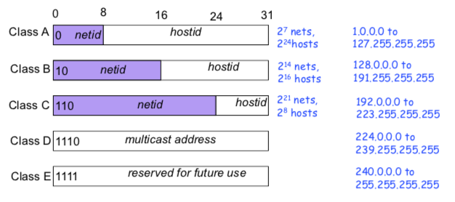

* Subnetting
  + Net ID (mask 1)
  + subnet ID (mask 1), part of bits from original hostID
  + host ID (mask 0)
* Supernetting

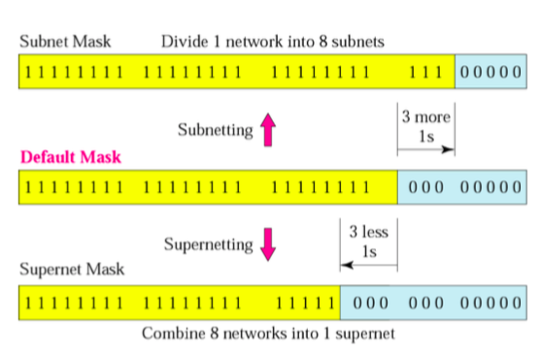

* + 3 rules (for class C networks)
    - The number of blocks must be a power of 2 (2, 4, 8, 16, …)
    - The blocks must be contiguous in the address space (no gaps between the blocks)
    - If the number of blocks is N, the third byte must be divisible by N

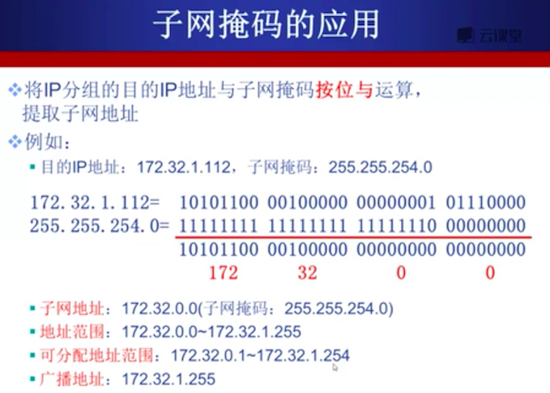

* CIDR (Classless Inter Domain Routing)
  + Subnet portion of address of arbitrary length
  + Address format: a.b.c.d/x, where x is # bits in subnet portion of address
  + Route aggregation: longest prefix matching
* IP addresses: how to get one?
  + Hard-coded by system admin in a file
  + DHCP (Dynamic Host Configuration Protocol) 动态主机配置协议
    - Dynamically get address from a server
* DHCP
  + Goal: allow host to dynamically obtain its IP address from network server when it joins network
    - Can renew its lease on address network
    - Allows reuse of address
    - Support for mobile users who want to join network (more shortly)
  + Overview:
    - Host broadcasts “DHCP discover” message
    - DHCP server responds with “DHCP offer” message
    - Host requests IP address: “DHCP request” message
    - DHCP server sends address “DHCP ack” message
  + DHCP is realised in Application layer
    - DHCP → UDP → IP → Ethernet → physical link
  + DHCP uses UDP and port number 67 (server side) and 68 (client side)
  + DHCP offer message includes IP address, length of lease, subnet mask, DNS servers, default gateway
* NAT (network address translation)
  + All datagrams leaving local network have same single source NAT IP address and different source port numbers
  + NAT router must:
    - Outgoing datagrams: replace (src IP, port #) to (NAT IP, new port #)
    - Remember in NAT translation table
    - Incoming datagrams: replace (NAT IP, new port #) to (src IP, port #)
  + NAT advantages
    - Range of addresses not needed from ISP: just one IP address for all devices
    - Can change addresses of devices in local network without notifying outside world
    - Can change ISP without changing addresses of devices in local network
  + NAT disadvantages
    - NAT violates the architectural model of IP
      * Every IP address uniquely identifies a single node on Internet
      * Routers should only process up to layer 3
    - NAT changes the Internet from connectionless to a kind of connection oriented network
  + NAT controversies:
    - Routers should only process up to layer 3
    - Violates end-to-end argument
    - Address shortages should instead be solved by IPv6
  + NAT traversal problem
    - Solutions:
      * inbound-NAT 静态配置
        + E.g. 138.76.29.7, port 2500 always forwarded to 10.0.0.1 port 25000
      * UPnP Internet Gateway Device (IGD) Protocol. Allows NATed host to 自动配置
        + Learn public IP address
        + add/remove port mappings (with lease times)
      * Relaying 中继 (used in Skype)
        + Relay bridges packets between two connections